Bahria University,

Karachi Campus

LAB EXPERIMENT NO.

**05**

LIST OF TASKS

|  |  |
| --- | --- |
| TASK NO | OBJECTIVE |
|  |  |
| 1 | Write the same program with small variation i.e. this time the program will ask for 3 integers twice and displays the result for each addition separately; Output will look like as follows:  Enter 3 integers for 1st addition  2  2  2  Enter 3 integers for 2nd addition  3  3  3 |
| 2 | Write an assembly program that Multiply two number within the range of 10. |
| 3 | Write an assembly program that Divide two number within the range of 10 |
| 4 | Write an assembly program that Read and Print Hello world. |
| 5 | Write an assembly program that add two number within the range of 10. |
| 6 | Write an assembly program that subtract two number within the range |

Submitted On:

2/11/2022

(Date: DD/MM/YY)

TASK NO #1: Write the same program with small variation i.e. this time the program will ask for 3 integers twice and displays the result for each addition separately; Output will look like as follows:

Enter 3 integers for 1st addition

2

2

2

Enter 3 integers for 2nd addition

3

3

3

**SOLUTION:**

.data

prompt: .asciiz "Plz Enter Firstt Three Number :\n"

prompt1: .asciiz "\nPlz Enter Second Three Number :\n"

prompt2: .asciiz "\nThe Addition Of First Three Numbers Is :\n"

prompt3: .asciiz "\nThe Addition Of Second Three Numbers Is :\n"

.text

main:

li $v0,4

la $a0,prompt

**OUTPUT:**

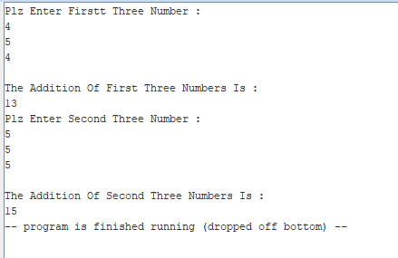

syscall

li $v0,5

syscall

move $t0,$v0

li $v0,5

syscall

move $t1,$v0

li $v0,5

syscall

move $t2,$v0

add $t0,$t0,$t1

add $t1,$t0,$t2

li $v0,4

la $a0,prompt2

syscall

li $v0,1

move $a0,$t1

syscall

##############################

li $v0,4

la $a0,prompt1

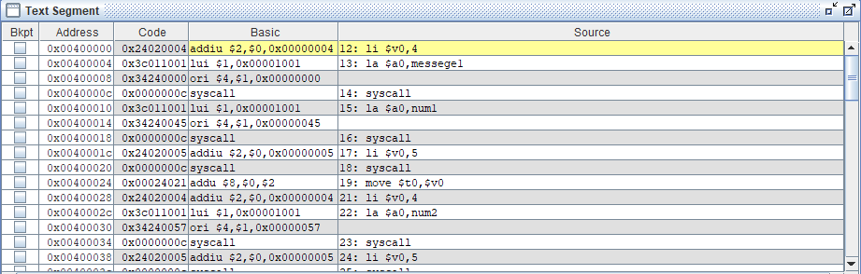

syscall

li $v0,5

syscall

move $t0,$v0

li $v0,5

syscall

move $t1,$v0

li $v0,5

syscall

move $t2,$v0

add $t0,$t0,$t1

add $t1,$t0,$t2

li $v0,4

la $a0,prompt3

syscall

li $v0,1

move $a0,$t1

syscall

**TASK 2:**Write an assembly program that Multiply two number within the range of 10.

**SOLUTION:**

.data

prompt: .asciiz "Plz Enter first Number :\n"

prompt1: .asciiz "Plz Enter second Number :\n"

subb: .asciiz "The multiplication OF Two Numbers is :"

.text

main:

la $a0,prompt

li $v0,4

syscall

**OUTPUT:**

li $v0,5

syscall

move $t0,$v0

la $a0,prompt1

li $v0,4

syscall

li $v0,5

syscall

move $t1,$v0

mul $t2,$t0,$t1

la $a0,subb

li $v0,4

syscall

#result calling

li $v0,1

move $a0,$t2

syscall

**TASK 3:** Write an assembly program that Divide two number within the range of 10.

**SOLUTION:**

.data

prompt: .asciiz "Plz Enter first Number :\n"

prompt1: .asciiz "Plz Enter second Number :\n"

subb: .asciiz "The Division OF Two Numbers is :"

.text

main:

la $a0,prompt

li $v0,4

**OUTPUT:**

syscall

li $v0,5

syscall

move $t0,$v0

la $a0,prompt1

li $v0,4

syscall

li $v0,5

syscall

move $t1,$v0

div $t2,$t0,$t1

la $a0,subb

li $v0,4

syscall

#result calling

li $v0,1

move $a0,$t2

syscall

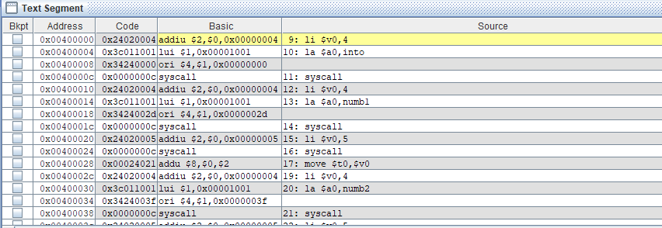

**TASK 4:** Write an assembly program that Read and Print Hello world.

**SOLUTION:**

.data

prompt: .asciiz "Plz Enter Your Message :"

prompt1: .asciiz "\nYour Message is :"

name: .space 20

.text

main:

**OUTPUT:**

li $v0,4

la $a0,prompt

syscall

li $v0,8

la $a0,name

li $a1,20

syscall

move $t1,$a0

li $v0,4

la $a0,prompt1

syscall

li $v0,4

move $a0,$t1

syscall

**TASK 5:** Write an assembly program that add two number within the range of 10.

**SOLUTION:**

.data

prompt: .asciiz "Plz Enter first Number :\n"

prompt1: .asciiz "Plz Enter second Number :\n"

sum: .asciiz "The Sum OF Two Numbers is :"

.text

main:

la $a0,prompt

li $v0,4

syscall

li $v0,5

syscall

**OUTPUT:**

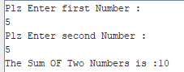

move $t0,$v0

la $a0,prompt1

li $v0,4

syscall

li $v0,5

syscall

move $t1,$v0

add $t2,$t0,$t1

la $a0,sum

li $v0,4

syscall

#result calling

li $v0,1

move $a0,$t2

syscall

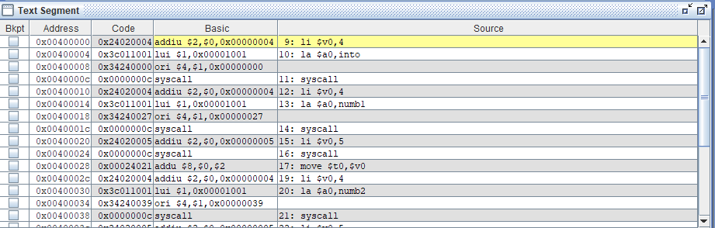

**TASK 6:** Write an assembly program that subtract two number within the range.

**SOLUTION:**

.data

prompt: .asciiz "Plz Enter first Number :\n"

prompt1: .asciiz "Plz Enter second Number :\n"

subb: .asciiz "The subtraction OF Two Numbers is :"

.text

main:

la $a0,prompt

li $v0,4

syscall

li $v0,5

**OUTPUT:**

syscall

move $t0,$v0

la $a0,prompt1

li $v0,4

syscall

li $v0,5

sisals

move $t1,$v0

sub $t2,$t0,$t1

la $a0,subb

li $v0,4

syscall

li $v0,1

move $a0,$t2

syscall

